**Test Case 0009 (part 1)**

**System:** VirtuCardsClient & VirtuCardsHost

**Description:** Test that verifies that the game handles legal and illegal moves properly

**Severity:** 3

**Instructions**

1. Start VirtuCardClient application
2. Click the button labeled “Sign In”
3. Enter “virtucards01@gmail.com” into the text input labeled “Enter email…”
4. Enter “Testing1” into the text input labeled “Enter password…”
5. Press the button labeled “Login”
6. A window should appear saying “Login Success”
7. Press the OK button that appears on that window
8. Start VirtuCardHost application
9. Repeat steps 2-7 but on the VirtuCardHost application
10. The checkbox “Allow Host to Join” should be checked on the host
11. Press the Create Game button
12. In the VirtuCardClient application enter the 6-character room code found on the host’s screen into the field labeled “Enter Code…”
13. Press the Join Game button on the client
14. After the name TestCase0001 appears in the player list on the host side, press the Start Game button
15. Press the drawcard button until the cards run out
16. Press the Playcard until the cards on your hand run out

**Expected Result:** When the players spam the Playcard button while having all of the cards in the hand, the player will be able to play every card and see the cards in hand are shrinking until the player reaches card Nine. When that happens, the player will not be able to play that card.

**Test Case 0009 (part 2)**

**System:** VirtuCardsClient & VirtuCardsHost

**Description:** Test that verifies that the game handles legal and illegal moves properly

**Severity:** 3

**Instructions**

1. Start VirtuCardClient application
2. Click the button labeled “Sign In”
3. Enter “virtucards01@gmail.com” into the text input labeled “Enter email…”
4. Enter “Testing1” into the text input labeled “Enter password…”
5. Press the button labeled “Login”
6. A window should appear saying “Login Success”
7. Press the OK button that appears on that window
8. Start VirtuCardHost application
9. Repeat steps 2-7 but on the VirtuCardHost application
10. The checkbox “Allow Host to Join” should be checked on the host
11. Press the Create Game button
12. In the VirtuCardClient application enter the 6-character room code found on the host’s screen into the field labeled “Enter Code…”
13. Press the Join Game button on the client
14. After the name TestCase0001 appears in the player list on the host side, press the Start Game button
15. Press the drawcard button
16. If the card you receive is not Nine, press the Playcard button

**Expected Result:** When the Playcard button was played and the card was not Nine, it means that the card is a valid card to play, so the turn will move on to the next person, and the game with continue.

**Test Case 0009 (part 3)**

**System:** VirtuCardsClient & VirtuCardsHost

**Description:** Test that verifies that the game handles legal and illegal moves properly

**Severity:** 3

**Instructions**

1. Start VirtuCardClient application
2. Click the button labeled “Sign In”
3. Enter “virtucards01@gmail.com” into the text input labeled “Enter email…”
4. Enter “Testing1” into the text input labeled “Enter password…”
5. Press the button labeled “Login”
6. A window should appear saying “Login Success”
7. Press the OK button that appears on that window
8. Start VirtuCardHost application
9. Repeat steps 2-7 but on the VirtuCardHost application
10. The checkbox “Allow Host to Join” should be checked on the host
11. Press the Create Game button
12. In the VirtuCardClient application enter the 6-character room code found on the host’s screen into the field labeled “Enter Code…”
13. Press the Join Game button on the client
14. After the name TestCase0001 appears in the player list on the host side, press the Start Game button
15. Press the drawcard button
16. If the card you receive is Nine, press the Playcard button

**Expected Result:** When the Playcard button was played and the card was Nine, it means that the card is an invalid card to play, so the turn will not move on to the next person, and it is still the user’s turn.

**Test Case 0009 (part 4)**

**System:** VirtuCardsClient & VirtuCardsHost

**Description:** Test that verifies that the game handles legal and illegal moves properly

**Severity:** 3

**Instructions**

1. Start VirtuCardClient application
2. Click the button labeled “Sign In”
3. Enter “virtucards01@gmail.com” into the text input labeled “Enter email…”
4. Enter “Testing1” into the text input labeled “Enter password…”
5. Press the button labeled “Login”
6. A window should appear saying “Login Success”
7. Press the OK button that appears on that window
8. Start VirtuCardHost application
9. Repeat steps 2-7 but on the VirtuCardHost application
10. The checkbox “Allow Host to Join” should be checked on the host
11. Press the Create Game button
12. In the VirtuCardClient application enter the 6-character room code found on the host’s screen into the field labeled “Enter Code…”
13. Press the Join Game button on the client
14. After the name TestCase0001 appears in the player list on the host side, press the Start Game button
15. Press the drawcard button
16. If the card you receive is Nine, press the Playcard button

**Expected Result:** When the Playcard button was played and the card was Nine, it means that the card is an invalid card to play. The game screen on the client-side will show a UI that says “Invalid Move!” for a second and fade away.

**Pictures**

Part 1 & part 2

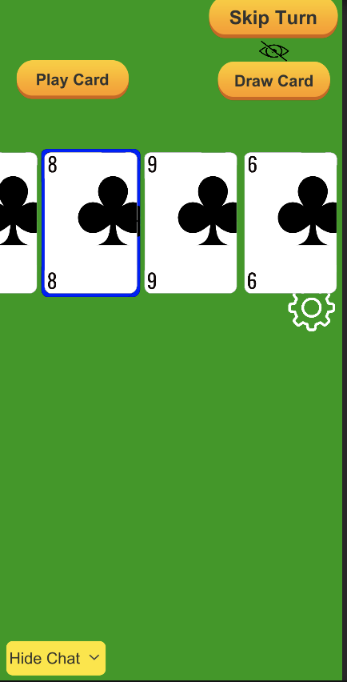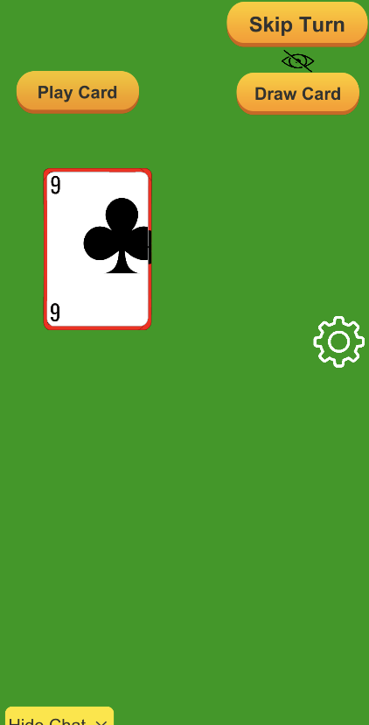

The first picture shows that all of the cards have been drawn from the deck and the whole deck is inside the players hand. When the player play a card, the turn will switch go on to the next player (pt 2). However, since I am the only person in the game, it is my turn again, so I played card that is not number nine since that is the only card that cannot be played.

Part 3 & part 4

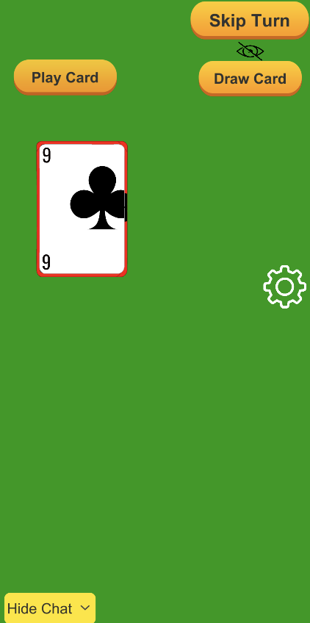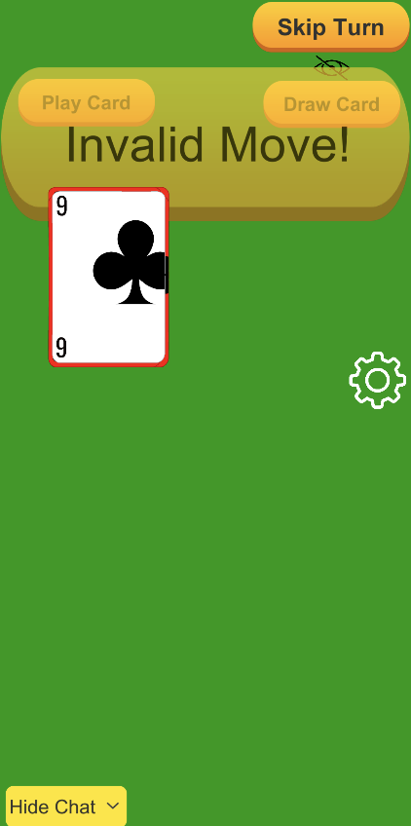

When a player tries to play nine, it shows an “invalid move!” sign and fade in less than a second. The third picture shows that it is still the user’s turn to play something because nothing has been played.